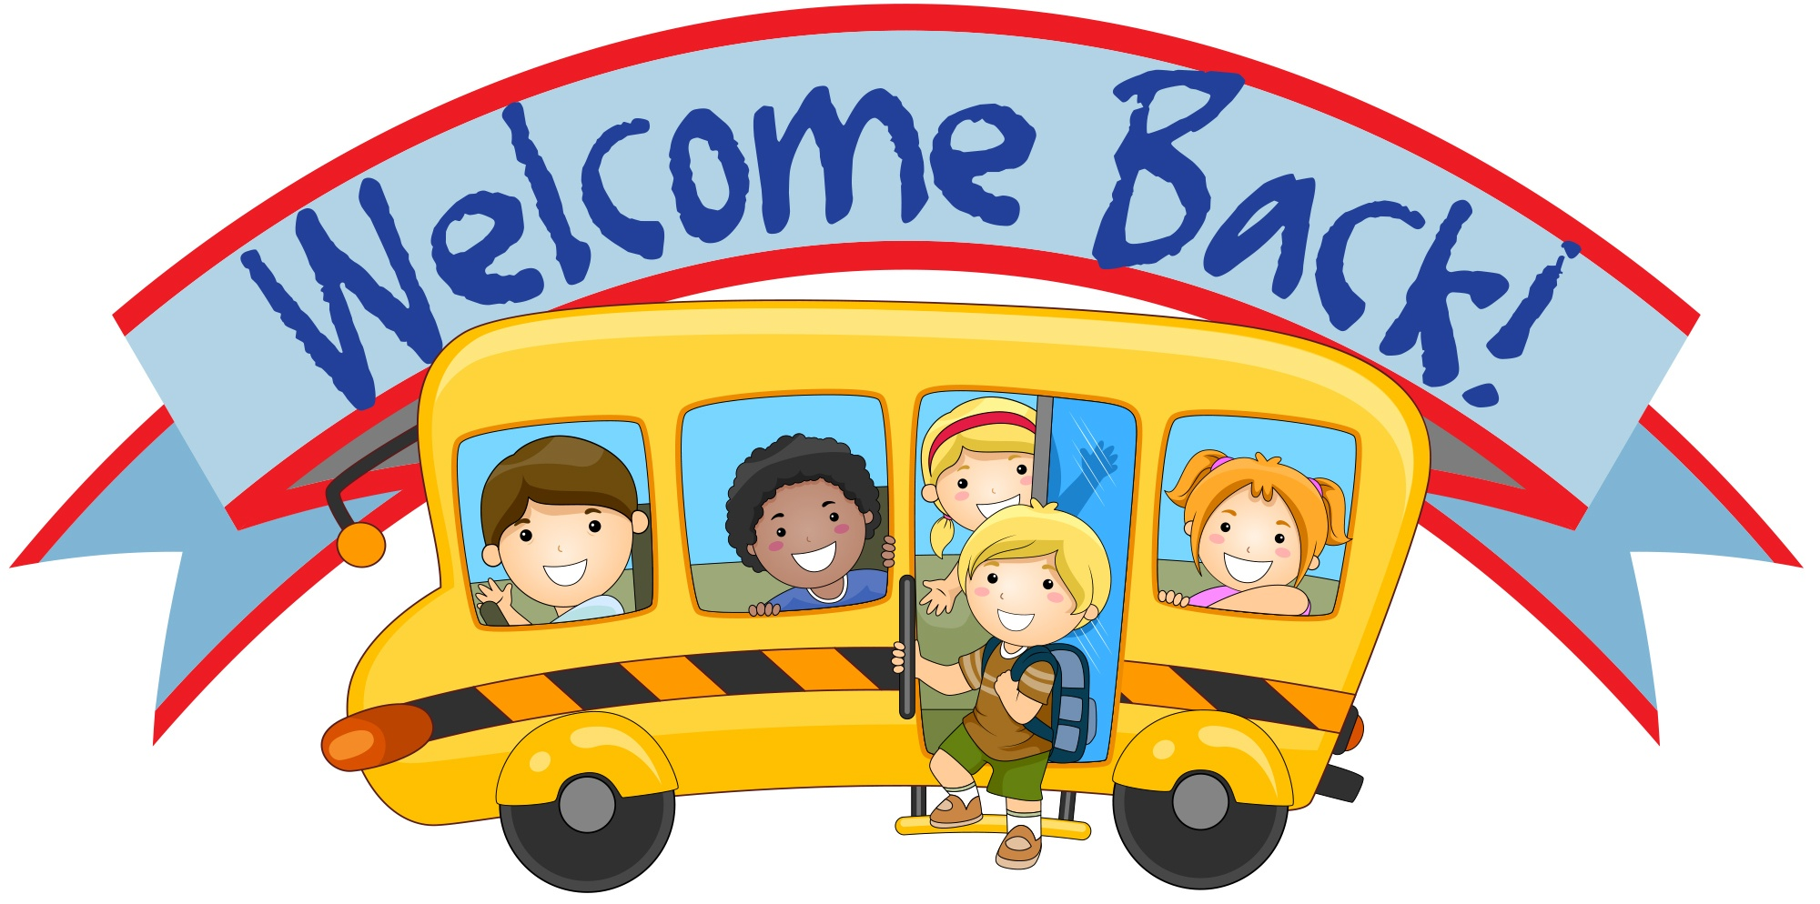
August 9, 2022

Dear Third Grader,

Welcome to the third grade and Greene Intermediate School. I am very excited to have you in my class and am looking forward to a fun filled year. There is so much for us to learn and discover together. The year will also give the opportunity for many friendships to be made. We will all work together to learn and reach our goals. This year we will have Mrs. Glover, Mrs. Livingston and Mrs. Bull working in our classroom to help us all learn as much as we possibly can.

The Intermediate School will be hosting a “Meet and Greet” on Wednesday, September 7, 2022, from 2:00 pm to 3:00 pm. Our classroom is room 21.

Third grade is full of information and life-long skills. We will learn together in a safe and happy way. Some of the new things you will learn this year will be cursive writing, multiplication, division and most importantly we will focus on our talents that make us special. There will be lots of work, but we will also have time to work on projects and learn cooperatively throughout our days.

Enjoy the rest of the summer and I will see you on the first day of school which is Thursday, September 8, 2022. Please remember to read and practice your math facts for the remainder of the summer!

Sincerely your teacher,
Mrs. Browning

